**Simple Harmonic Motion Application – User Documentation**

The Shiny application ‘Simple Harmonic Motion’ allows users to select values of key variables (mass, spring force, and damping factor) and to see the corresponding frequency and amplitude plotted for the un-damped and damped system.

To use the application, enter in values as per the below diagram.

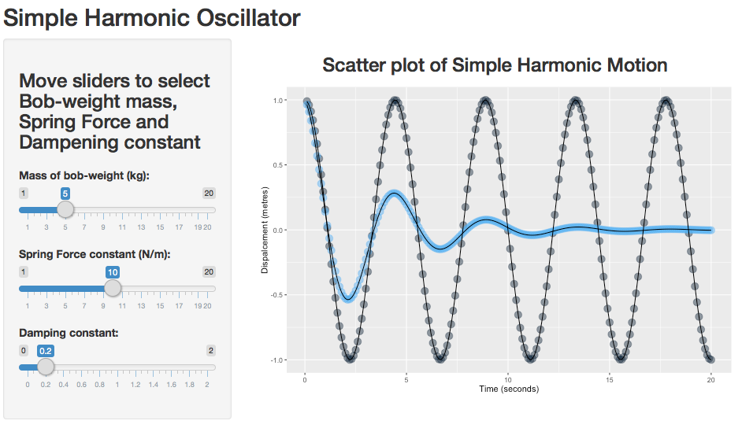

Use sliders to adjust values for Damping Factor, Spring Force and Mass

View the calculated un-damped (black) and damped (blue) motion